**Graphical User Interface**

* First interface:-
* When the code is ran a small interface (given below) will pop up and it will take one input as a number 1 or 2. If 1 is typed then it will recognize number and if 2 is typed then it will recognize commands like “ON”, “OFF”, “INCREASE”, “DECREASE” etc.

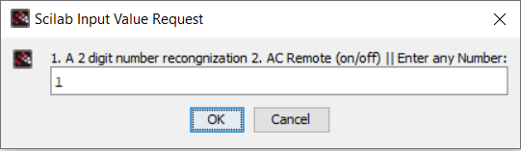

* Second interface:-

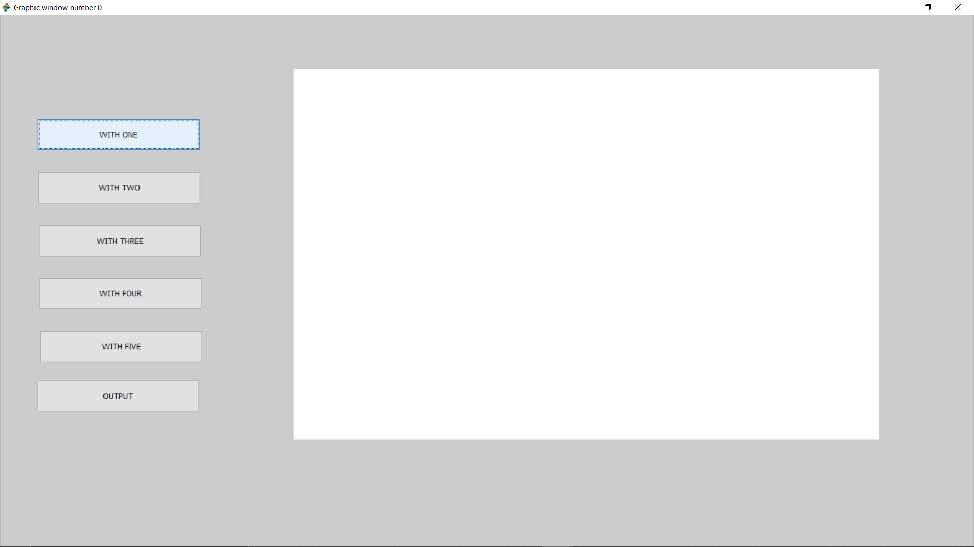

* When the first input is 1 then an audio of the input file will be played and the above prompt will appear.
* There are 6 buttons, first five buttons plots cross correlation between input file and each number. And last button will give output.

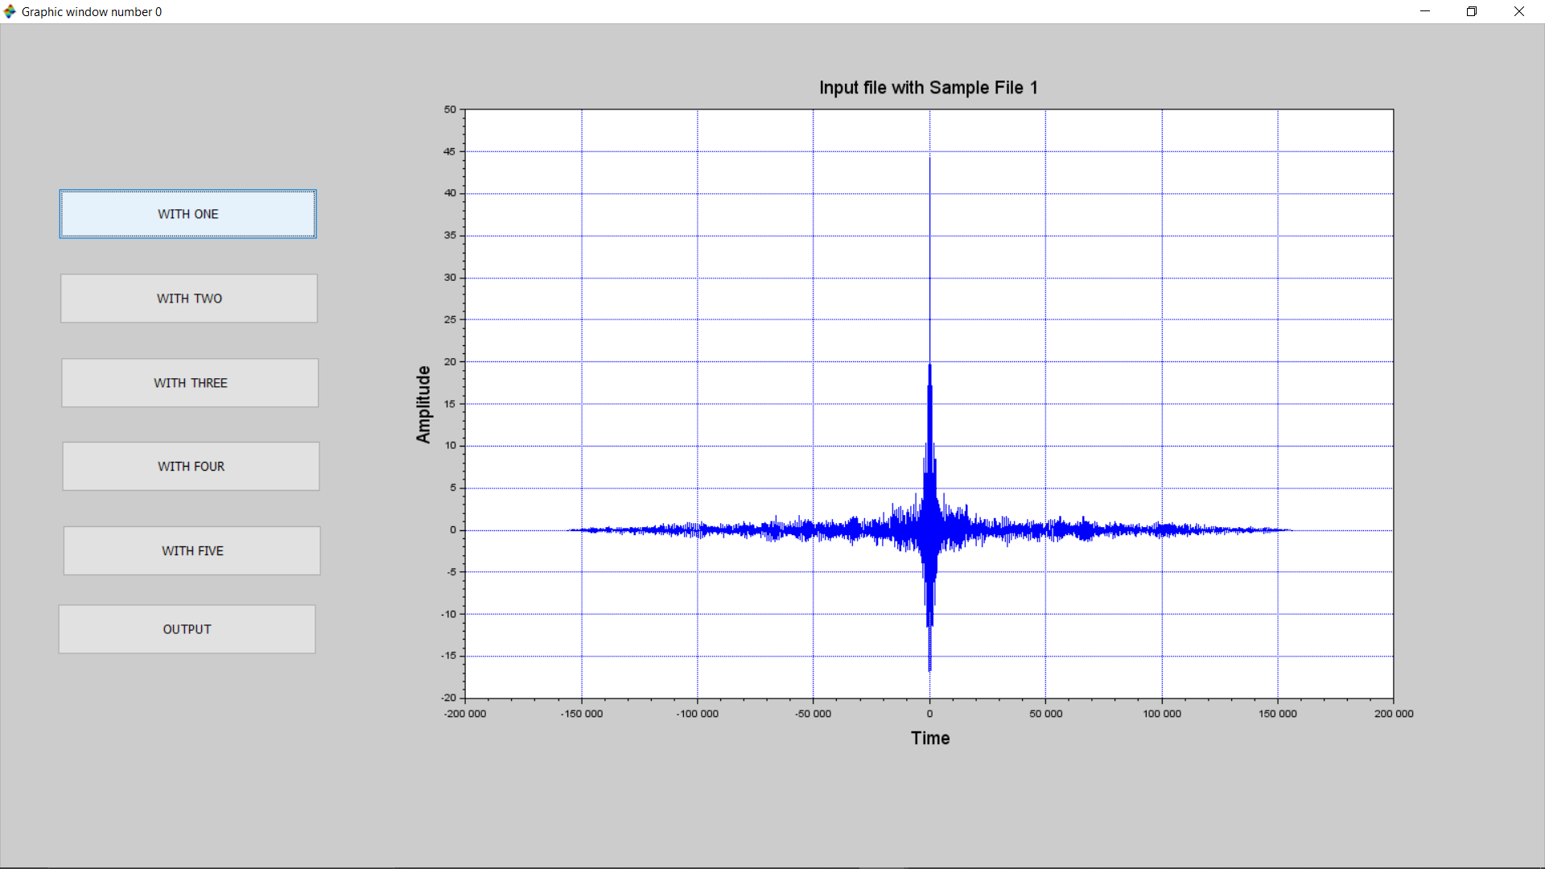

* If we press “WITH ONE” the correlation graph between wave “one” and input wave will be displayed on the right side of the screen.
* Same will happen when the other keys are pressed.

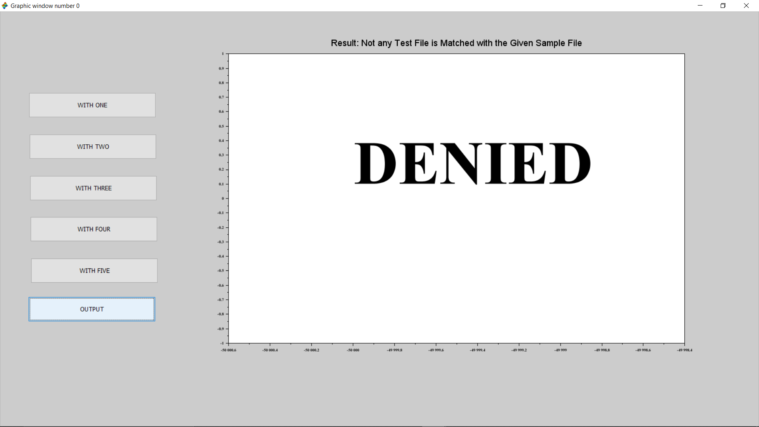

* If the maximum correlation is less than threshold then the input file will not match with any other file from dataset so an audio file of “access denied” will be played and “DENIED” will be written on the screen.

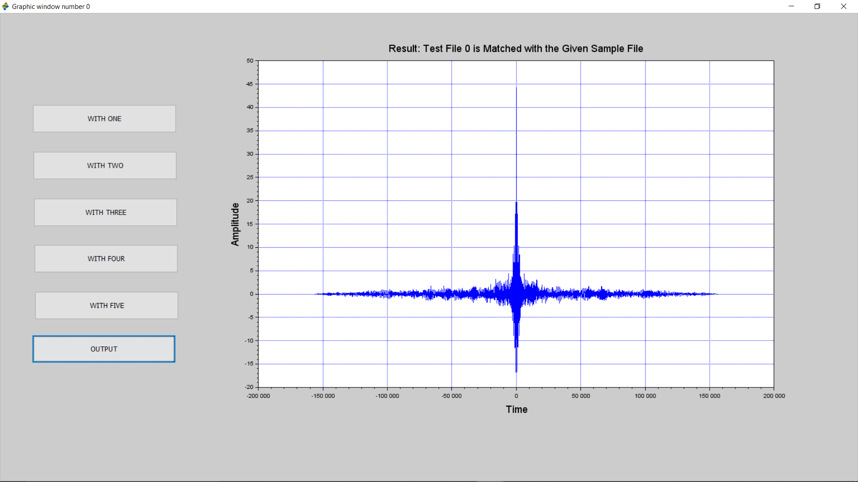

* If the input file matches with any other file from dataset, then it will show the correlation graph of that file with input file and an audio file of “access granted” will be played.
* Third interface:-

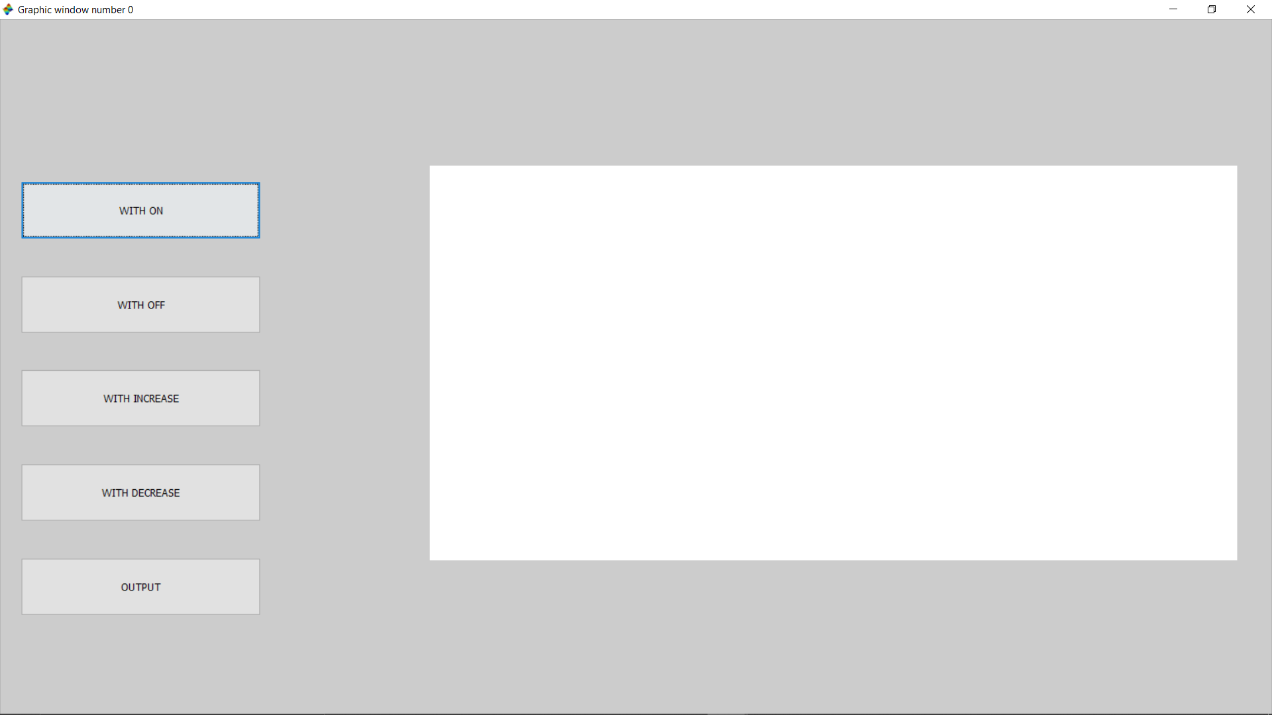

* When the first input is 2, audio of the input file will be played and the above prompt will appear.
* There are 5 buttons in the prompt and first five buttons will give correlation of “ON”, “OFF”, “INCREASE” and “DECREASE” with input file and the last button will give output.

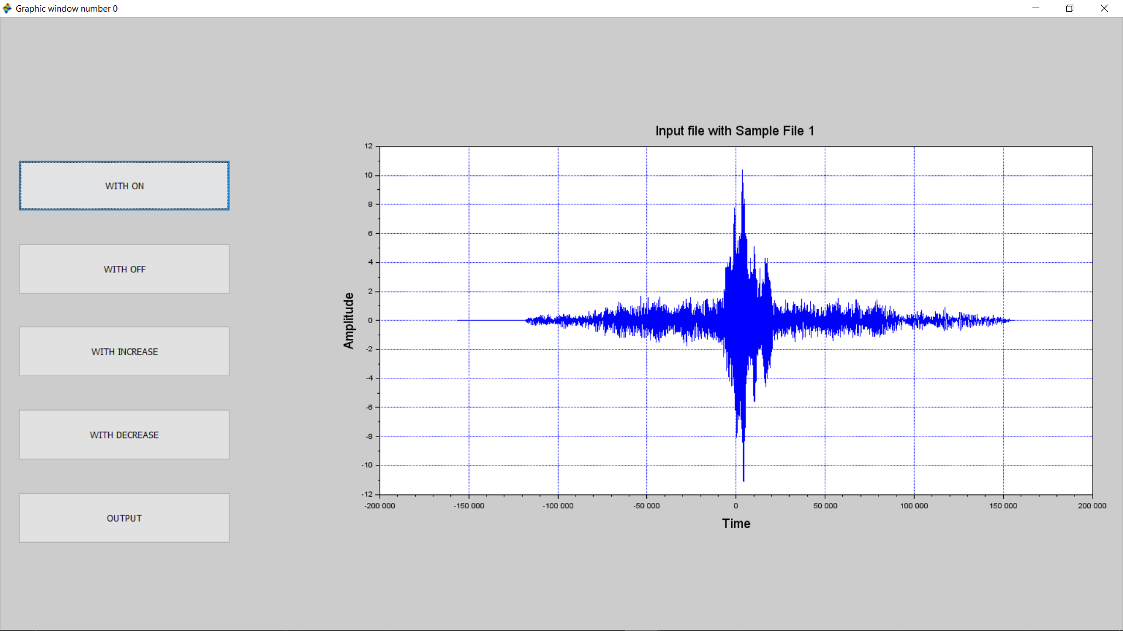

* If “WITH ON” button is pressed then correlation graph between input file and “on” file will be displayed on the right side.
* Same thing will happen for “OFF”, “INCREASE” and “DECREASE”.
* When output key is pressed, if the input file does not match with any other file from the dataset then an audio file of “access denied” will be played and “DENIED” will be written on the screen. This will be shown same as second interface.
* When output key is pressed, if the input file matches with any other file from the dataset then, an audio file of access granted will be played and the graph of the correlation between that matched file and input file will be played. This will also be shown same as second interface.